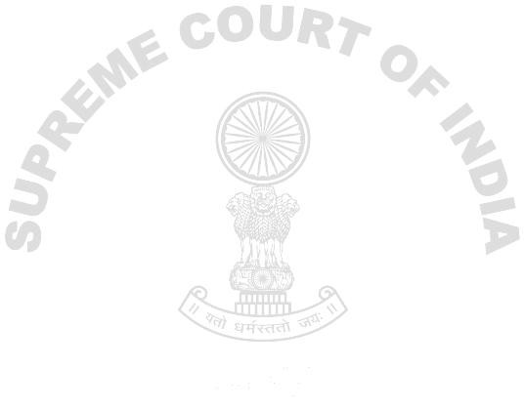5-Years Notional Weightage Case at Hon’ble SC

Case Details

STATUS PENDING

Appeal Civil 5195 / 2010

Petitioner VIJAYA BANK
Vs.
Respondent NEELA ARUN MOHILE & ORS.

Advocate(Petitioner) MR. RAJIV NANDA

Advocate(Respondent) MR. VENKATESWARA RAO ANUMOLU

Appealed Against High Court Details - Not Available

Matter is Connected To Connected Details - Not Available

Subject Matter SERVICE MATTERS - RETIRAL BENEFITS

Listing Details Next Date of Listing - 03/12/2013

Tuesday, August 27, 2013 - 2:46:59 PM

We have impleaded in the above case

