ALL INDIA BANK RETIREES’ FEDERATION (REGD.)
D/1/ Sector C Scheme No. 71 Indore 452009
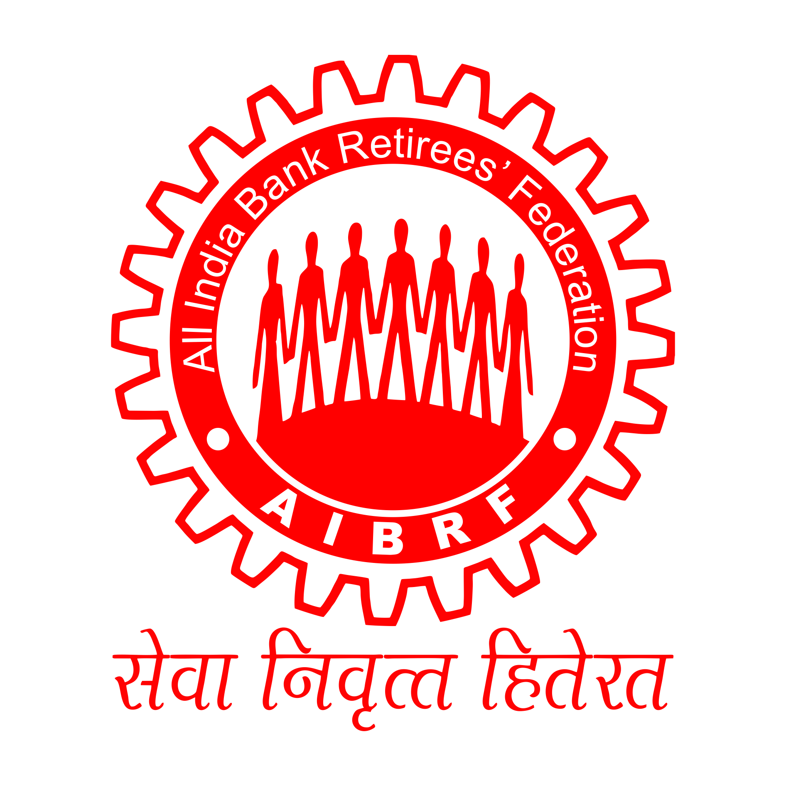
E-Mail ID sharbat_123@rediffmail.com Mobile: 8966019488
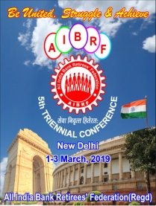 SILVER JUBILEE YEAR (1994-2019)

Ref. No 019/339 07.12.2019

The Office Bearers/ Central Committee Members
A.I.B.R.F

Dear Comrades.
Re: Office Bearers and Central Committee Meetings held at Lucknow from
4th December 2019 to 6th December 2019
Proceedings/ Decisions taken in the meetings.
Office Bearers’ Meeting was held on 4th December 19 and Central Committee Meeting was held on 5th & 6th December 2019. Office Bearers’ meeting was attended by 41 office Bearers and 27 participated in the deliberations. Central Committee Meeting was attended by 132 central committee members besides 41 office bearers and 58 central committee members participated in the deliberations.

2. General Secretary presented the report before the house which contained the following issues concerning the bank retirees.
(a) Macro level economic issues in particular affecting bank retirees and senior citizens.
(b) Review of progress made on various decisions taken and resolutions passed in 5th National Conference held in Delhi in March 2019
( c) Merger of Public Sector Banks and future strategy to protect interest of retirees in particular of retirees of 10 banks directly affected by the proposed merger announced by FM in August 2019.
(d) Review of Group Medical Insurance Policy for retirees
(e) Status of Retiree demands/issues in ongoing bipartite negotiations
(f) Status of other pending issues of retirees
(g) Organizational issues and financials
(h) Future Strategy to achieve pending demands.
3. After the comprehensive deliberations in both the meetings, the following unanimous decisions were taken

- AGITATIONAL/ STRRUGLE PROGRAMS ON CONTINIOUS BASIS All the participants expressed the concern for undue delay taking place in finalizing the settlement as well as the pending issues of retirees are not reaching to finality and taking concrete shape causing anxiety and anger among more than 4 lakhs retirees. In view of this position and to strengthen hands of UFBU during the negotiation, it was decided to launch indefinite, long, sustainable and massive and effective ACTION PROGRAMS WITH IMMEDIATE EFFECT in all parts of the country. All 41 office Bearers and 132 committee members gave commitment and assurance to take all possible steps to make the programs successful and to carry it as long as needed by the organization. It was also decided to inform this decision of AIBRF to DFS/ IBA and UFBU leadership. Support of UFBU and other sister retiree organizations will be solicited to make our programs successful. Details of Action programs to be launched are given below.
- Group Medical Insurance Scheme for retirees was reviewed. All participants were of unanimous view that the premium rates have reached to the unbearable level for most of the retirees and unless corrective steps are taken for reduction of premium considerably it may force more and more retirees to come out of the scheme putting question mark on its continuity in coming days. The central committee further resolved its earlier commitment to ensure that reliable and affordable insurance scheme is available for one and all. It was noted that various suggestions given by AIBRF to reduce the premium were not considered favorably at the time of its renewal in November 2019 despite continuous efforts were made. However now there are indications from UFBU leadership that suggestions of AIBRF like reduction in bed charges to Rs. 4000 per day, introduction of multiple slabs of sum assured instead of present two, packages for specified deceases, uniform subsidy for payment of premium by banks etc. will be discussed for consideration during the negotiation to ensure that premium becomes affordable for all section of retirees. It was resolved and decided that AIBRF will gear up its efforts for reduction in GST rates on premium as well as hospitalization bills for senior citizens including submission of memorandum to FM and State FMs in this matter. The committee expressed thanks to the leadership of AIBEA for their initiative in submission of memorandum to various state FMs for reduction in GST rates from the present 18 per cent for senior citizens on premium payable on group policy. The committee also resolved that AIBRF would wait for the out come of the settlement on this issue and would explore other options if needed for reduction of premium so group policy can be taken by all section of retirees. It was also decided that AIBRF would make efforts to ensure that AIBRF get bigger and effective role in deciding terms and conditions of the scheme.
- The committee took note of the status on pending issues of retirees being raised by UFBU leadership during the negotiation on various dates before IBA for consideration and sanction. Issues being raised are (a) Improvement in Family Pension as per RBI formula (b) Updation of Pension as per RBI formula(c) To consider grade pay for computation of basic pension for all those retired in 2012 and subsequently. (d) Improvement in Group Medical Scheme for retirees as per the suggestions given by AIBRF. The committee also took note of the organizational efforts made by AIBRF which included Action programs conducted in the months from April to June 2019, submissions of representations to IBA, UFBU. DFS etc. on pending demands of retirees independently as well as jointly with CBPRO, carrying out cost exercise on pension Updation and submission of our notes to constituents of UFBU and , participations in meetings organized by constituents of UFBU to draw strategy on retiree issues etc. However, committee expressed its concern on undue delay taking place in conclusion of bipartite talks and sanction of retiree demands. After comprehensive deliberations on the issue took unanimous decision to (a) keep close liaison and coordination with UFBU leadership for resolution of the above 4 demands which were considered ACHIEVEABLE in this settlement. (b) To continue to make all organizational efforts including action programs on continuous basis for early conclusion of settlement and sanction of at least 4 demands in it (c) to seek support of UFBU leadership in our organizational efforts and (d) gear up our organizational machinery at all levels to organize action programs successfully.
- The committee also did compressive review of other pending issues of retirees like sanction of stagnation increments for the purpose of computing basic pension to award and officer staff those retired from 2012 to 2015, pension option to resignees, uniform DA to all etc. and decided to pursue at organizational level for early resolution.
- The committee did review of various issues demands of retirees which are already sanctioned as per the courts verdict, IBA advice etc. but still not implemented in many banks. Such issues identified were (a) Non- payment of commutation arrears in the matter of 1616-1684 as per Supreme Court judgment and wrong interpretation of the judgment by IBA/ bank managements on this issue(b) Non- implementation of Supreme Court judgment on 1616-1684 issue in many private sector banks as per IBA advice. (c) Non- implementation of IBA advice on grant of benefit of notional service to specialist officers and pension option to compulsorily retired employees by many banks (d) grant of stagnation increments for computation as per the settlement not implemented in many banks ( e) grievance cell not functioning in many banks even after 10 years of introduction of the scheme (f) non-payment of leave encashment to compulsorily retired employees from 2002 as per IBA advice (g) Non-implementation of Supreme Court decision in the matter of Kool Case by many banks despite IBA advice. (h) Implementation issues of Pension Scheme in RRBs being faced by retirees etc. The committee made appeal to affiliates to take up the issues with the management for implementation on continuous basis and refer to AIBRF Central Office for support needed. Organizational efforts will be escalated wherever required for solution.
- Merger of 10 Banks: The issue was raised by many central committee members particularly by those who are directly affected. AIBRF stand is unambiguous and clear. It is against such mergers which are against the public interest and work force. To protect interest of retirees in post-merger scenario, to ensure availability of benefits to retirees as per the best practices and smooth functioning of affiliates in coordinated and effective manner, the concerned affiliates were advised to carry out consultation among themselves on organizational issues as per the guidelines issued by AIBRF and model scheme drawn for 3banks earlier. After getting feedback from them, joint meeting will be convened by AIBRF to take final view on the issue.
- It was noted by the Committee that on the basis of follow up done by AIBRF with IBA, IBA has advised member banks to consider payment of arrears in respect of commutation difference as per Supreme Court judgment in the matter of 1616-1684. Many banks have started making payments of arrears. However some of our affiliates and activists are of the view that method of simultaneous recovery of commuted amount adopted by banks as per IBA advice is not in accordance of Supreme Court Judgment and extent guidelines of government in this regard. Therefore the eligible retirees will not get correct arrears. Considering this position the committee took decision to constitute sub -committee under the convener ship of DGS Shri S.V. Srinivasan and Vice President Shri T.K Subramanian was constituted who will examine all legal aspect of the issue and suggest future strategy to be adopted in this regard. Separate letter will be sent by AIBRF to the committee in this regard.
- Organizational issues and developments were discussed and the committee taken note of them. Accounts of 5th National Conference were presented which were approved unanimously. Final Accounts of AIBRF as on 31.03.2019 duly audited by statutory auditors were presented to the house which were adopted unanimously. It was informed that all statuary returns under Trade Union Act have since been filed up to 31.12.2018. Invitation given by V.P. Shri Laxman Rao for holding next central committee in Tirupati was noted. Decision on it will be taken in due course.
- The Committee unanimously approved proposal moved by GS to create 3 positions of permanent invitees in CC Committee for women in addition to 2 nominated CC Members among women. Further the house authorized the President and General Secretary to finalize the names with due consultation.
- The committee unanimously identified tow macro level issues for taking up with authorities for resolution by AIBRF as part of the society and to serve senior citizens of the country (a) Increase in DICGC Cover for bank deposits in particular for deposits of senior citizens (b) Improvement in terms of deposit scheme meant for senior citizen deposit scheme of the government for better yield and longer duration. The Central Office was directed to take appropriate steps in this regard.
- The committee also discussed the quantum of ex-gratia payments being paid to pre-1986 retirees. It was noted that they all are Super Senior Citizens with minimum age of 93 years. The present quantum is very paltry and needs immediate revision. It was decided to pursue the issue vigorously with the authorities for increase in it. It was noted with thanks that AIBEA is also pursuing this issue with authorities.
- The committee thanked to UFBU and its constituents for raising the issues of retirees during the negotiation and decided to appeal them to continue to purse for their final sanction before signing the settlement.
- The committee conveyed its profound thanks to U.P. State Committee, its leadership and entire team of volunteers and workers for all possible efforts made by them and taking pains to make the meetings huge success. It was noted with happiness that the present leadership of U.P. State Committee has created new enthusiasm and zeal among the membership of the area through their continuous organizational efforts.

With Warm Greetings,

Yours Sincerely,
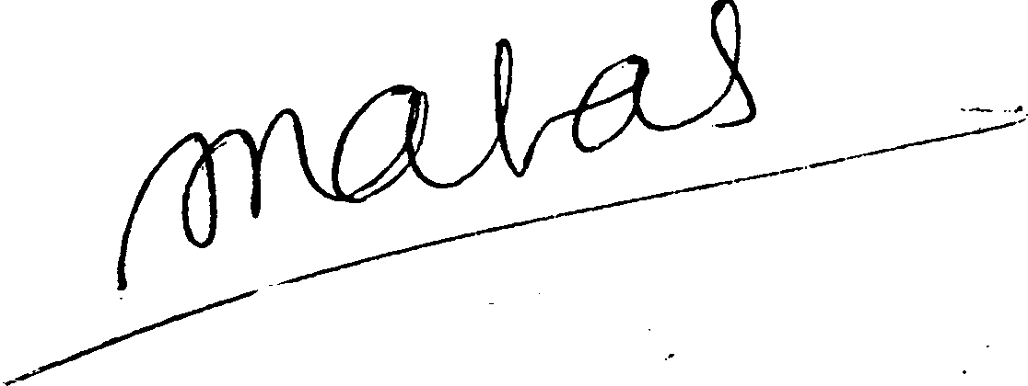

(S.C.JAIN)
GENERAL SECRETARY

PROPSED ACTION PROGRAMS TO BE LAUNCHED BY AIBRF
IN SUPPORT OF PENDING DEMANDS OF RETIREES- DETAILS

- First Phase of Action Programs to be launched with immediate effect and to be concluded by 31.01.2020

- It will be carried out under overall supervision and control of State Committees

- State Committees will immediately identified the centers where action programs to be organized and inform to the central office immediately.

- In each city/ center areas to be identified for assembling group of activists/ retirees at least twice in week for minimum 2 hours on each occasion with display of ply cards with retiree issues / demands to secure public support for them. Simultaneously efforts will be made to obtain signatures of public on petition containing retiree issues. Petition draft is being finalized at Central Office and will be sent shortly. As many as points in each city to be identified for this program.

- On conclusion of the above, one centralized Dharna program should be organized in each city where maximum retirees should be mobilized. Signatures of the retirees on the petition to be obtained which will be submitted to PMO/ Chief Justice of India/ FM/ DFS/ IBA/ UFBU for immediate resolution of the issues included in the petition.

- As far as possible, video recording of the program may be done and uploaded on You Tube for publicity.

- Efforts should be made to ensure coverage of our action programs in media.

- Periodical report may be sent to Central Office on such programs by State Committees

- Teams may be constituted at State Committee level/ Regional Level/ Center Level for effective implementation of Action Programs.

- All programs need to be organized with enthusiasm, zeal and commitment.

- Participations of Super Senior Citizens, Family Pensioners, women and other vulnerable section of retirees may be mobilized

BANK RETIREE UNITY ZINDZBZD AIBRF ZINDABAD

