Ref:2017/47 Date: 31.03.2017

The Office Bearers/ Central Committee Members/ State Body Chiefs
A.I.B.R.F

Dear Comrades,

Re SLP filed by United Bank of India Management
Against decision of Kolkata High Court decision
In the matter of 100 per cent DA
Re: Hearing on 31.03.2017

The above SLP came up for hearing in the Supreme Court today to decide on its admission.

2. Considering the importance of issue involved in it affecting large number of retirees, it is decided that AIBRF would take all steps to handle in Supreme Court in consultation with the United Bank of India Retired employees Welfare Association who are the original petitioner in this case. Accordingly AIBRF has engaged Senior Counsel to argue the case in today’s hearing.

3. In today’s proceedings , after hearing both the parties, the bench has decided to hear other parties of SLP namely IBA, Government of India before taking decision on its admission for regular hearing.

4. AIBRF shall take necessary steps to effectively and forcefully place all relevant facts before the court on the next date of hearing and will obtain legal opinion from some more senior advocates expert in service matters for this purpose. AIBRF will also consider joining the SLP if needed as per the legal opinion.

5. Next date of hearing is yet to announced by the court. All affiliates are requested to circulate only this communication of AIBRF in this matter.

With Greetings,

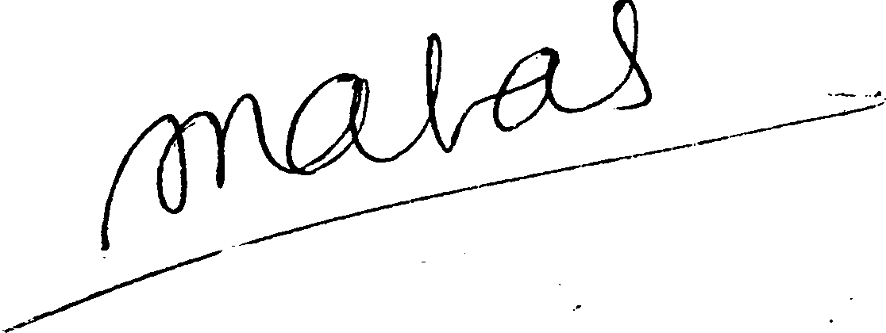
Yours Sincerely,

( S.C.JAIN)
GENERAL SECRETARY

